|  |
| --- |
|  |

**Procedure for the Simulation of NOx Emissions Produced by Combustion Turbines**

**SIM-00001-Nox**

**Revision: 1**

**Status: Issued**

July 2016

**CONFIDENTIAL**

© Copyright 2015 SimGenics LLC

**Proprietary Class 2**

CHANGE HISTORY

|  |  |  |  |  |
| --- | --- | --- | --- | --- |
| Configuration Control | | | | |
| **Created by:** | | Franli Laubscher | | |
| **Original creation Date:** | | 01 July 2016 | | |
| Revision History | | | | |
| **Revision** | **Date** | | Author | Description of Changes |
| A | 12-July-2016 | | Franli Laubscher | Draft issue |
| B | 12-July-2016 | | Francois Laubscher | Review of Document |
| 1 | 20-July-2016 | | Franli Laubscher | Updates |
| 1A | 1-September-2020 | | Francois Laubscher | Test git |
|  |  | |  |  |
|  |  | |  |  |

|  |  |  |  |
| --- | --- | --- | --- |
| Authorization | | | |
| **Action** | **Designate / Signature** | **Position** | **Date** |
| Prepared | \_\_\_\_\_\_\_\_\_\_\_\_\_\_\_\_\_\_\_\_ |  |  |
| Reviewer | \_\_\_\_\_\_\_\_\_\_\_\_\_\_\_\_\_\_\_\_ |  |  |
| Approver | \_\_\_\_\_\_\_\_\_\_\_\_\_\_\_\_\_\_\_\_\_ | Management Representative |  |

*Original Signed Copy at Configuration Management Centre (CMC)*

Contents

[1. Purpose 5](#_Toc456776657)

[2. SCOPE 5](#_Toc456776658)

[3. References 5](#_Toc456776659)

[4. Definitions, Terms, Acronyms and Abbreviations 5](#_Toc456776660)

[5. Procedure 6](#_Toc456776661)

[5.1 ADDING THE AMMONIA 6](#_Toc456776662)

[5.2 CHANGING THE REACTION RATES FOR CORRECT NOX EMISSIONS IN THE FLAME 7](#_Toc456776663)

[5.2.1 ADJUSTING THE REACTION RATE VALUE 7](#_Toc456776664)

[5.2.2 ADJUSTING THE REACTION RATE FACTOR 8](#_Toc456776665)

[5.3 FUNCTION GENERATOR OF THE FOGGER 10](#_Toc456776666)

[5.4 THE CHEMICAL REACTION USING AMMONIA TO REDUCE NITROGEN OXIDES 11](#_Toc456776667)

[5.5 CALCULATING OMEGA (Ω) 14](#_Toc456776668)

[6. Verification and validation 15](#_Toc456776669)

[6.1 TEST ANALYSIS AT STEADY STATE 15](#_Toc456776670)

[6.2 TEST ANALYSIS AT STARTUP 16](#_Toc456776671)

[6.3 TEST ANALYSIS AT SHUTDOWN 19](#_Toc456776672)

[7. Appendix 21](#_Toc456776673)

**Figures**

[Figure 5‑1: Mixed Fluids Window 7](#_Toc456776674)

[Figure 5‑2: NOx Reaction in Flame Model 8](#_Toc456776675)

[Figure 5‑3: Function Generator for the Reaction Rate Factor 9](#_Toc456776676)

[Figure 5‑4: NO Mass Fraction at Turbine Exit 9](#_Toc456776677)

[Figure 5‑5: Fogger Illustration 10](#_Toc456776678)

[Figure 5-6: Function Generator of the Fogger 11](#_Toc456776679)

[Figure 5-7: The Balanced Chemical Reaction to Reduce NOx Emissions [3] 11](#_Toc456776680)

[Figure 5-8: Mass Fractions from Turbine Exit and Ammonia Injection 12](#_Toc456776681)

[Figure 5-9: Mole Rate for Turbine Exit and Ammonia Injection 12](#_Toc456776682)

[Figure 5-10: Mole Rate of the Reaction 12](#_Toc456776683)

[Figure 5-11: Added Efficiency to the Reaction Mole Rate 13](#_Toc456776684)

[Figure 5-12: Total Mole Rate 13](#_Toc456776685)

[Figure 5-13: Conversion from Mole Rate to Mass Flow Rate 13](#_Toc456776686)

[Figure 5-14: Final Mass Fractions 14](#_Toc456776687)

[Figure 5-15: Total Mass Fraction 14](#_Toc456776688)

[Figure 5-16: NOx and Ammonia Slip ppm Calculations 14](#_Toc456776689)

[Figure 5-17: Water Injection and Gas Supply Mass Flow Rates 14](#_Toc456776690)

[Figure 5-18: Calculation of Omega 15](#_Toc456776691)

[Figure 6‑1: NOx Emissions of the Long Beach Simulator at Startup 16](#_Toc456776692)

[Figure 6‑2: NOx Emissions of the Test Simulator at Startup 17](#_Toc456776693)

[Figure 6‑3: Omega Value for Long Beach - and the Test Simulator at Startup (Sensor Dynamics not Included) 18](#_Toc456776694)

[Figure 6‑4: Ammonia Slip for Long Beach - and the Test Simulator at Startup 18](#_Toc456776695)

[Figure 6‑5: NOx Emissions of the Long Beach Simulator at Shutdown 19](#_Toc456776696)

[Figure 6‑6: NOx Emissions of the Test Simulator at Shutdown 20](#_Toc456776697)

[Figure 6‑7: Omega Value for Long Beach - and the Test Simulator at Shutdown 20](#_Toc456776698)

[Figure 6‑8: Ammonia Slip for Long Beach – and the Test Simulator at Shutdown 21](#_Toc456776699)

**Tables**

[Table 6‑1: Steady State NOx Emissions Analysis 15](#_Toc456703420)

**Abbreviations and Acronyms**

| **Abbreviations** | **Description** |
| --- | --- |
| NOx | Nitrogen Oxides |
| SCR | Selective Catalytic Reduction |
| Ω | Omega |
| ppm | Parts per Million |

# Purpose

This document describes the formation and simulation of NOx emissions produced by combustion turbines, using the SimuPact Flame Model.

# SCOPE

NOx emissions are formed by the combustion of nitrogen and oxygen in furnace flames, and rapidly increase when the flames reach temperatures above 1800°F [4]. These emissions are a big cause for concern as they can combine with other pollutants in the atmosphere to form O3, or ground level ozone, as well as nitric acid, which is harmful to the environment.

In order to limit the amount of emission gases discharged, aqueous ammonia is diluted which, through a process called selective catalytic reduction (SCR), will break down the NO molecules to form by-products such as water and nitrogen gases.

# References

|  |  |  |
| --- | --- | --- |
| **Reference** | Title | Rev/Date |
| 1. NOx and SOx | Chemistry of NOx Formation | 03/14/2016 |
| 1. NRGLB | Long Beach Open Cycle Combustion Turbine Simulation | SAT Version |
| 1. NOx and SOx | NOx – Sources and Control Methods | NOx.ppt |
| 1. Alentecinc | The formation of NOx |  |
| 1. Wikipedia | Ammonium Hydroxide | 07/11/2016 |
| 1. Wikipedia | Selective Catalytic Reduction | 07/01/2016 |
| 1. Wikipedia | Parts-per Notation | 06/05/2016 |

# Definitions, Terms, Acronyms and Abbreviations

|  |  |
| --- | --- |
| **Thermal NOx (nitrogen oxides)** | A generic term used to describe mostly NO (nitric oxide) and NO2 (nitrogen dioxide) that form when nitrogen and oxygen combusts at high temperatures. NO contributes to approximately 90-95% of the NOx emissions released into the atmosphere. |
|  |  |
| **Fogger** | A device that injects water vapor into the inlet air mixture, thus lowering the flame temperature and decreasing the NOx emissions. |
|  |  |
| **Aqueous Ammonia** | A solution of ammonia in water [5]. The fraction of ammonia needed for the reaction will depend on the efficiency of the catalyst bed. |
|  |  |
| **Selective Catalytic Reduction (SCR)** | A method of converting the NO emissions, with the support of a catalyst bed and the aqueous ammonia, into diatomic nitrogen (N2) and water (H2O) [6]. |
|  |  |
| **Ammonia Slip** | The unreacted ammonia that passes through the SCR bed [2]. |
|  |  |
| **Omega (Ω)** | The ratio of the mass flow of the water injection flowing into the flame over the mass flow of the gas supply entering the flame [2]. |
|  |  |
| **Parts per million (ppm)** | This is a unit that describes the concentration of small values with dimensionless quantities, e.g. mole fractions or mass fractions [7]. |

# Procedure

The following procedures can be followed after the entire flow diagram is setup with all the nodes and boundary conditions defined. To ensure the operations explained below will be successful, the first step is to confirm that the diagram is able to solve and produce answers in steady state.

## ADDING THE AMMONIA

Depending on the quality of the inlet air, the injected water, and the supplied gas, the top five gases present in the mixture after combustion will be varying amounts of CO2, H2O, N2, NO, and O2. Although ammonia (NH3) is not a product of the combustion process, this compound will have to be added to the list of mixed gases in order for one to be able to change the mass fraction on another node in the future. To add NH3 to the list, complete the following steps:

* Under *Charts/Lookup Tables,* expand the *Flow Solver* and choose *Materials and Fluids.* For the purpose of this example, *Mixed Fluids* were used. Expand *Des Moines* and double click on *Mixed Gases*.
* A window, as shown in **Figure 5-1** on the next page, will appear. Under the *Pure Gas Mixture* tab, double click on *Matheson – NH3,* and it will shift over to the window on the right. Click OK. Ammonia has now been added to all the nodes used in your diagram.

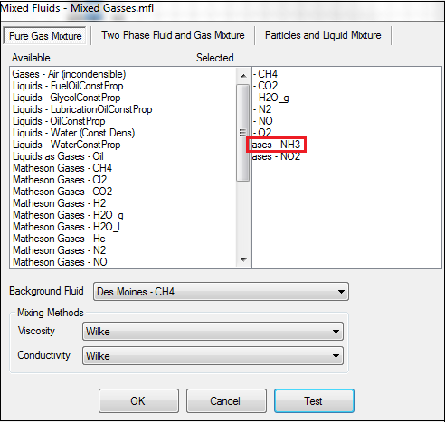Figure 5‑1: Mixed Fluids Window

## CHANGING THE REACTION RATES FOR CORRECT NOX EMISSIONS IN THE FLAME

In the flame model, there are four major chemical reactions that occur when combustion takes place. The quantity of the products formed after each reaction will vary according to the amounts that enter the combustion chamber. In order for the correct amount of NOx emissions to be released, as specified by the plant data, the *reaction rate value* together with the *reaction rate factor* need to be adjusted accordingly.

### ADJUSTING THE REACTION RATE VALUE

* Click on the flame model and scroll down to *Reaction Chain* (as circled in red)*.* Below the reaction chain data, there will be four balanced chemical reactions. Scroll down until the reaction (also circled in red) as displayed in **Figure 5-2** on the next page, is found.

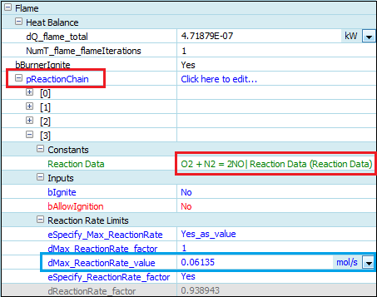Figure 5‑2: NOx Reaction in Flame Model

* As mentioned before, both the chemical reaction’s *reaction rate value* and *reaction rate factor* will have to be adjusted. The reaction rate value will limit the amount of NO moles that are produced every second. As seen in **Figure 5-2** above, the value (circled in blue) was changed until there were no more than 13.5 ppm NOx emissions present at the turbine exit.

### ADJUSTING THE REACTION RATE FACTOR

The flame’s temperature will increase if either the fogger, or the water injection, or both are to be switched off. It will be very difficult to change the *reaction rate value* manually every time there is a fluctuation in the temperature. Therefore, the *reaction rate factor* will act as a multiplier to the *reaction rate value,* and will be changed by means of a function generator. Follow the steps below to pair the correct *reaction rate factor* with the flame.

* Insert a function generator, from the *DCS Library*.
* Using a *Data Transfer Link*, connect the temperature of the flame to the input of the function generator.
* The function generator will interpolate linearly between the number of X-values and Y-values that are inserted. On the function generator listed below, **Figure 5-3**, there are six points inserted. The X-values correspond to the flame temperature (°C is used in this example), and the Y-values correspond to the *reaction rate factor*. The X-values should be inserted according to what the flame temperature is, if the fogger and water injection are switched on or shut off respectively. The corresponding Y-values should be changed in order to reflect what the plant data indicates the NOx emissions should be at these various temperatures.

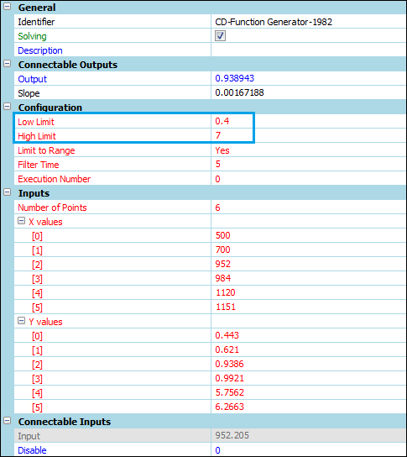Figure 5‑3: Function Generator for the Reaction Rate Factor

* Set the high and low limits so that the Y-values fall in between these limitations (as depicted in blue in **Figure 5-3** above).
* Use a *Data Transfer Link* to connect output of the function generator to the *reaction rate factor* of the flame.
* To see how the quantity of the products change as the *reaction rate value* and the *reaction rate factor* change, the mass fractions at the turbine exit can be examined. **Figure 5-4** below, indicates that the mass fraction of NO can be converted to ppm if multiplied by 1 x 106 in order to equal 13.5 ppm.

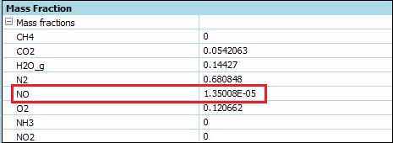Figure 5‑4: NO Mass Fraction at Turbine Exit

## FUNCTION GENERATOR OF THE FOGGER

The fogger’s influence on the temperature of the flame is relatively small, but it is still an important component that must be included in the design. In order to maximize the fogger’s influence follow the steps listed below:

* Insert a function generator, from the *DCS Library*.
* Using a *Data Transfer Link*, connect the opening of the valve to the input of the function generator as shown in **Figure 5-5**.
* In this instance, there are 3 points inserted on the function generator. The X-values will correspond to the opening of the valve and the Y-values will correspond to the amount of heat lost (AU) in the node. The air inlet entering the node is 23.5°C, which the fogger has to reduce to 17.5°C if the valve is fully open. Insert different Y-values until this desired temperature is reached at the node. See **Figure 5-6**.

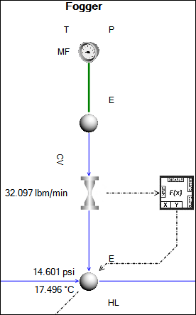

Figure 5‑5: Fogger Illustration

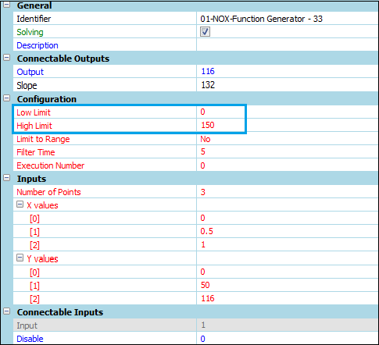Figure 5-6: Function Generator of the Fogger

* Remember to set the high and low limits for the Y-values to ensure the function generator will operate optimally. The limits are shown in blue in **Figure 5-6** above.
* The ambient temperature on the node is also added here as 40°F to ensure that there will be a heat loss occurring to the atmosphere.
* Using a *Data Transfer Link,* connect the output of the function generator to the heat leak (AU) of the node as shown in **Figure 5-5** on the previous page.

## THE CHEMICAL REACTION USING AMMONIA TO REDUCE NITROGEN OXIDES

The chemical reaction, as presented in **Figure 5-7**, involving the nitrogen oxides and diluted aqueous ammonia will be illustrated in a separate script (see Appendix for the completed code) where the final mass fractions will be calculated and transferred to a node representative of the SCR bed.

Figure 5-7: The Balanced Chemical Reaction to Reduce NOx Emissions [3]

The following instructions will be a guide to calculating the correct NOx emissions and Ammonia Slip.

* Insert a Scriptunder the *Scripting* tab in *Components*.
* Create input properties for each of the mass fractions coming from the turbine exit node and the ammonia injection node respectively. Use the *Data Transfer Link* to connect the various mass fractions to these properties. See **Figure 5-8** below.
* 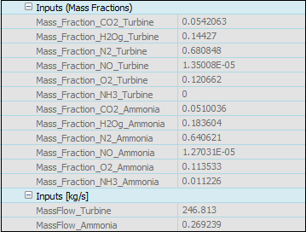Create two more input properties, also shown in **Figure 5-8**, to account for the mass flow rate at the exit of the turbine and the mass flow rate of the diluted ammonia. Use the *Data Transfer Tool* again to connect these properties. REMEMBER: To ensure all calculations are accurate, check that the units of the mass flow rates are in **kg/s** before connecting to the input properties.

Figure 5-8: Mass Fractions from Turbine Exit and Ammonia Injection

* 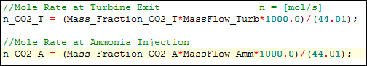Compute the mole rates [**mol/s**] for each individual gas present at the exit of the turbine and for the gases present in the diluted ammonia. To compute the mole rate, the mass fraction is multiplied by the mass flow rate, then divided by the molar mass of each gas. In order for the units to cancel out, it must be multiplied by a 1000. An example of the calculated mole rate, as it is written in the script, is expressed in **Figure 5-9** below.

Figure 5-9: Mole Rate for Turbine Exit and Ammonia Injection

* 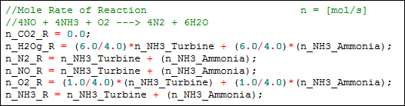It will now be necessary to compute the mole rate [**mol/s**] of the reaction. Since the ammonia is diluted, it will act as the limiting reactant. For every mole of ammonia used, products will form in relation to what their coefficient, in the balanced chemical equation, is. Refer back to **Figure 5-7** as a guide to the formation of products and dissolution of reactants. **Figure 5-10** shows the reaction for every gas present in the chemical equation.

Figure 5-10: Mole Rate of the Reaction

* 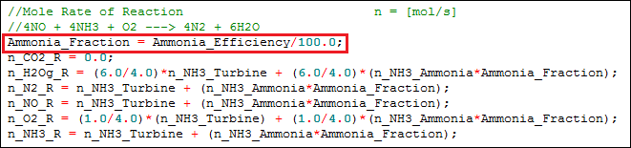It is important to notice that the ammonia will not react at 100% efficiency. There will be ammonia exiting the SCR bed, which is defined as the ammonia slip. Therefore, add the efficiency as an input property, and multiply it to the mole rate of the reaction as seen in **Figure 5-11**. The value for the efficiency can now be changed until the desired quantity of NOx emissions are produced.

Figure 5-11: Added Efficiency to the Reaction Mole Rate

* 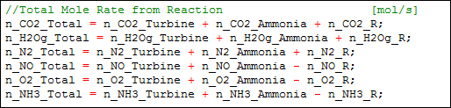The total mole rate [**mol/s**] can now be computed by adding the mole rate for each gas originating from the turbine exit and the mole rate for each gas originating from the ammonia injection. The mole rate of the reaction will be added or subtracted, depending whether products have been formed, or reactants have been used. The equation for each gas is demonstrated in **Figure 5-12** below.

Figure 5-12: Total Mole Rate

* The total mole rate [**mol/s**] for every gas, now needs to be converted back to mass flow rate [**kg/s**] in order to be displayed as a mass fraction at the SCR bed. This is achieved by multiplying each mole rate with the gases’ individual molar mass, and then dividing by a 1000 so that the units will be correct. The conversion from mole rate to mass flow rate is shown in **Figure 5-13**.

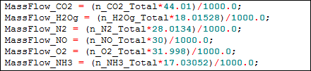

Figure 5-13: Conversion from Mole Rate to Mass Flow Rate

* Compute the total mass flow rate [**kg/s**] by adding the mass flow rate at the exit of the turbine and the mass flow rate of the diluted ammonia together.
* The final mass fractions can now be calculated by taking the individual mass flow rate of every gas and dividing it by the total mass flow rate. Examine **Figure 5-14** on the next page to see the calculations. REMEMBER: To prevent the denominator from being undefined when the total mass flow rate is zero, add a very small number (e.g. 1 x 10-6) to the total mass flow rate before 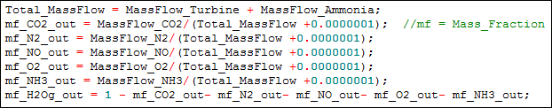dividing.

Figure 5-14: Final Mass Fractions

* \\simgenicsserver\samahnzi-us\SUS_Projects\NOx and SOx\Images\Figure4-15.pngBefore the mass fractions can be linked to the SCR bed, check that they add up to one (1). See **Figure 5-15** below.

Figure 5-15: Total Mass Fraction

* Finally, if the total mass fraction adds up to one, create output properties in the script in order to display the individual mass fractions for each gas to the outside world.
* Link the individual mass fractions for each gas to the boundary condition of the SCR node using the *Data Transfer Link*. The quantity of the NOx emissions can now vary if the efficiency at which the ammonia reacts is changed.
* \\simgenicsserver\samahnzi-us\SUS_Projects\NOx and SOx\Images\Figure4-16.pngCalculate the NOx emissions and ammonia slip, in ppm, by simply multiplying the NO and NH3 mass fractions at the SCR bed by 1 x 106 respectively, as done in **Figure 5-16**.

Figure 5-16: NOx and Ammonia Slip ppm Calculations

## CALCULATING OMEGA (Ω)

Omega is calculated as the ratio of the mass flow rate of the water injection flowing into the flame over the mass flow rate of the gas supply entering the flame. The following steps will require more data to be added to the existing script so that only a small calculation is needed to determine Omega.

* \\simgenicsserver\samahnzi-us\SUS_Projects\NOx and SOx\Images\Figure4-17.pngCreate two new input properties in the script and connect them, using the *Data Transfer Link*, to the mass flow rate of the water injection and to the mass flow rate of the gas supply. REMEMBER: Since Omega is a ratio, the units need to cancel out. Thus be sure to check that both properties are in the same unit. An example of the input properties are shown in **Figure 5-17**.

Figure 5-17: Water Injection and Gas Supply Mass Flow Rates

* \\simgenicsserver\samahnzi-us\SUS_Projects\NOx and SOx\Images\Figure4-18.pngCalculate Omega by dividing the mass flow rate of the water injection by the mass flow rate of the gas supply as in **Figure 5-18**. Remember to add the small value to the denominator in case the mass flow rate of the gas supply should equal zero.

Figure 5-18: Calculation of Omega

* Lastly, create an output property in the script in order to make Omega visible to the outside world.

# Verification and validation

To ensure that this new method for determining the NOx emissions, as described in the previous sections, is accurate enough to use on simulators in the future, it has been compared to the NRG Long Beach simulator. The Long Beach simulator makes use of empirical methods to determine the NOx emissions, as opposed to this new method that uses the gases’ mass fractions and flow rates. An analysis of the emissions were done at startup, shutdown, and while the simulators were running at steady state.

## TEST ANALYSIS AT STEADY STATE

At steady state (65 MW), the Long Beach simulator will produce the lowest quantity of NOx emissions. At the turbine exit, the emissions should equal to 13.5 ppm. When ammonia has been added to the system, the NOx emissions will reduce to 2.3 ppm. The following table, **Table 6-1**, compares the influence of the foggers, and the influence of the ammonia injection, on the presence of the NOx emissions. The water injection will always be switched on.

Table 6‑1: Steady State NOx Emissions Analysis

|  | **NRG Long Beach** | **New Method** |
| --- | --- | --- |
| Fogger ON  Ammonia ON | 2.3 ppm | 2.299 ppm |
| Fogger ON  Ammonia OFF | 13.5 ppm | 13.5 ppm |
| Fogger OFF  Ammonia OFF | 14.7 ppm | 14.35 ppm |
| Fogger OFF  Ammonia ON | 2.4 ppm | 2.91 ppm |
| Omega | 1.76 | 1.75 |
| Ammonia Slip with Fogger ON | 0.1 ppm | 5.874 ppm |

It can be observed from **Table 6-1,** that the new method for determining the NOx emissions, is very close to the values produced on the Long Beach simulator. Thus, it is possible that the new method can be considered for determining NOx emissions on other simulators. The ammonia slip is the only property that shows a significant difference between the two methods. The power plant data [2] indicates that the ammonia slip needs to be around 5 ppm, when the NOx emissions are 2 ppm. **It was noticed that the slip never changed on the Long Beach simulator, which proves that this value is incorrect**. Thus, it can be concluded that the ammonia slip determined from the new method would provide the more accurate number.

## TEST ANALYSIS AT STARTUP

When starting up a simulator, it is expected that the NOx emissions will have an increase in concentration, and then gradually reduce as steady state is reached. A study of the startup was done on both simulators in order to compare the accuracy of the new method to the values of the Long Beach simulator. **Figure 6-1** and **Figure 6-2** below indicates the differences and similarities in the two methods.

Figure 6‑1: NOx Emissions of the Long Beach Simulator at Startup

Figure 6‑2: NOx Emissions of the Test Simulator at Startup

NOTE:

Sensor Dynamics was not included in the Test Simulator.

From the figures above, it can be observed that the NOx emissions of the test simulator do not reach the same maximum concentration than that of the NOx emissions at the Long Beach simulator. At the Long Beach simulator, the emissions are much higher because more gas is initially injected than is needed, in order to get the shaft speed up to 3600 rpm. The test simulator was tested at constant shaft speed and constant gas supply. Had the test simulator been tested at varying shaft speeds and varying gas supply, the results would have been similar to the values obtained at Long Beach. This is true because the final concentrations of the NOx emissions, as the simulator approached steady state, proved to be exactly the same.

As mentioned before, Omega fluctuates when the gas supply - and water injection mass flow rates’ fluctuate. From **Figure 6-3**, on the next page, it can be seen that the Long Beach simulator’s Omega value, increased and decreased significantly before it reached a stable value. This oscillation in the ratio occurred because the simulator attempted to increase the shaft speed up to 3600 rpm as fast as possible, which caused water injection and gas supply to be uncontrolled. There was no fluctuation in the test simulator’s Omega, since the gas supply and water injection reached a constant value once the valves were opened. Apart from the oscillation, both simulators reached the same ratio as soon as the shaft speed reached a constant state.

Figure 6‑3: Omega Value for Long Beach - and the Test Simulator at Startup (Sensor Dynamics not Included)

It make sense for the ammonia slip to be present only when there is ammonia being injected into the system. From **Figure 6-4** below, it can be observed that the ammonia slip at Long Beach stays at a constant rate of 0.105 ppm throughout the entire startup, even when there is no ammonia present. This is incorrect. As mentioned before, the ammonia slip needs to be around 5 ppm when the simulator is at steady state, which close to the value obtained by the test simulator.

Figure 6‑4: Ammonia Slip for Long Beach - and the Test Simulator at Startup

## TEST ANALYSIS AT SHUTDOWN

The NOx emissions released by the simulators, ranging from steady state to shutdown, can be examined in this section. The emissions will again increase in concentration as the ammonia injection, foggers, and water injection are switched off, but will ultimately decrease to zero once there is no more gas supplied to the combustion chamber. Look at **Figure 6-5** below, and **Figure 6-6** on the next pageto compare the results between the Long Beach simulator and the test simulator.

Figure 6‑5: NOx Emissions of the Long Beach Simulator at Shutdown

From these figures, it can be observed that the NOx emissions on both simulators are very similar to each other when the ammonia injection, water injection, and foggers are switched off at the indicated time intervals. The concentration of the NOx emissions never exceed 98 ppm on either simulator, and after the gas supply is switched off, both simulators decrease to 0 ppm. Since both simulators yielded the same results, it proves that the test simulator (containing the new method) is functioning correctly.

NOTE:

Sensor dynamics was not included in the Test Simulator graphs on the next page.

Figure 6‑6: NOx Emissions of the Test Simulator at Shutdown

Figure 6‑7: Omega Value for Long Beach - and the Test Simulator at Shutdown

The Omega value on both simulators were also examined at shutdown. It can be seen from **Figure 6-7** on the previous page, that Omega was immediately decreased to zero, on both simulators, when the water injection was turned off. From the figure, is seems that the Long Beach simulator takes a little longer to reach zero; this is only because there might be time constants inserted into the simulator preventing the calculation from happening too fast and making the simulator unstable.

The ammonia slip for each simulator was also calculated starting at steady state and ending when both simulators were completely shut down. As observed in **Figure 6-8** below, the ammonia slip at the Long Beach simulator was kept at a constant rate of 0.105 ppm, even after the ammonia injection had been shut off. This is proven to be incorrect by the test simulator, which demonstrates that the ammonia slip decreases from 5.87 ppm to 0 ppm at the moment the ammonia injection is turned off.

Figure 6‑8: Ammonia Slip for Long Beach – and the Test Simulator at Shutdown

NOTE:

Sensor Dynamics was not included in the Test Simulator.

# Appendix

The completed script, containing the code for solving the chemical equation using mass fractions and mass flow rates, as explained in **Section 5.4** above, is shown here to serve as an example for solving other chemical reactions.

